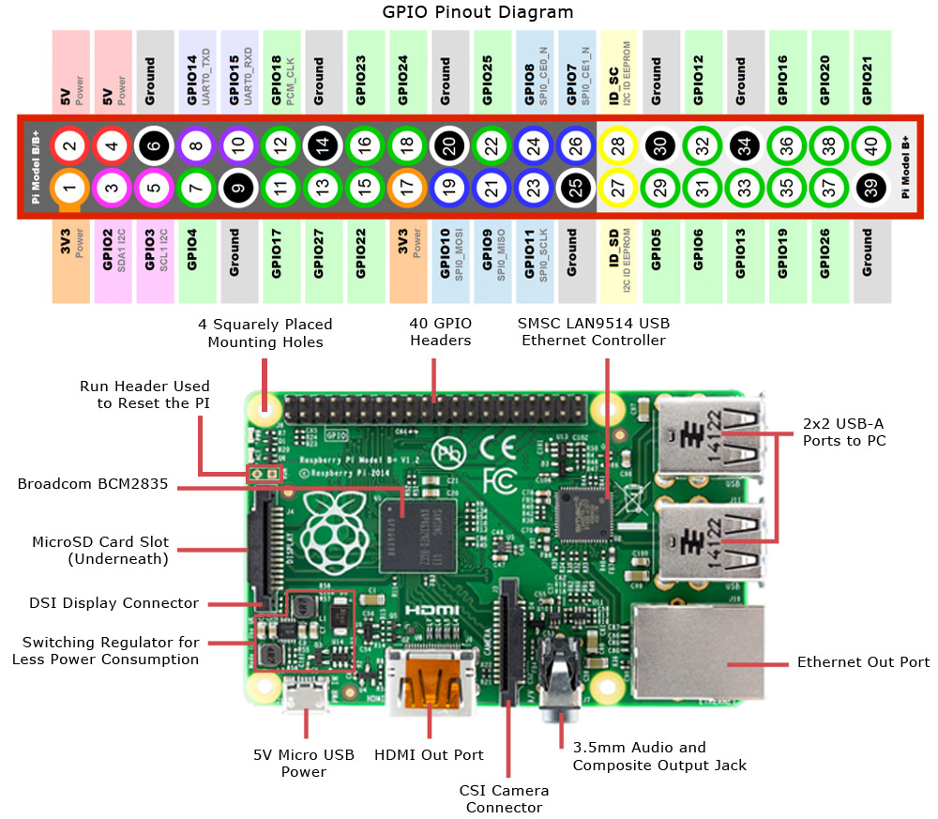

## SmartGarden Master Controller, HW v2.0 IO Pin Assignment

|  |  |  |  |
| --- | --- | --- | --- |
| RPi Connector PINS | Description | GPIO # | Assignment |
| 3 | SDA1 (I2C) | 2 | Reserved for I2C |
| 5 | SCL1 (I2C) | 3 | Reserved for I2C |
| 8 | TxD (Serial) | 14 | Serial |
| 10 | RxD (Serial) | 15 | Serial |
|  |  |  |  |
| 11 | GPIO | 0 | Input button 1 |
| 12 | PWM0/GPIO | 1 | Input button 2 |
| 13 | GPIO | 2 | Input button 3 |
| 15 | GPIO | 3 | Input button 4 |
| 16 | GPIO | 4 | OpenSprinkler-DAT |
| 18 | GPIO | 5 | OpenSprinkler-CLK |
| 22 | GPIO | 6 | OpenSprinkler-LAT |
| 7 | GPCLK0/GPIO | 7 | OpenSprinkler-NOE |
|  |  |  |  |
| 19 | MOSI/GPIO12 | 12 | Reserved for SPI |
| 21 | MISO/GPIO13 | 13 | Reserved for SPI |
| 23 | SCLK/GPIO14 | 14 | Reserved for SPI |
| 24 | CE0 (SPI) | 10 | Reserved for SPI |
| 26 | CE1 (SPI) | 11 | Reserved for SPI |
|  |  |  |  |
| 27 | SDA0 (ID EEPROM) |  | N/A |
| 28 | SCL0 (ID EEPROM) |  | N/A |
|  |  |  |  |
| 29 | GPIO | 21 | LCD hookup D4 |
| 31 | GPIO | 22 | LCD hookup D5 |
| 33 | GPIO | 23 | LCD hookup D6 |
| 35 | GPIO | 24 | LCD hookup D7 |
| 37 | GPIO | 25 | LCD hookup EN |
| 32 | GPIO | 26 | LCD hookup RS |
| 36 | GPIO | 27 | DHT21 sensor hookup |
| 38 | GPIO | 28 | Available |
| 40 | GPIO | 29 | Available – External hookup 2 |
|  |  |  |  |
|  | Need Analog input |  | External hookup 1 (configured as Thermistor sensor) |